EDS Theory Activity no. 1

Dataset :- Grocery

Name :- Ankush Ramesh Dudhe

Div :- CS6

Batch :- C63

Roll No. :- CS6-65

PRN :- 202401080044

* **Solution for formulated problem statement.**
* 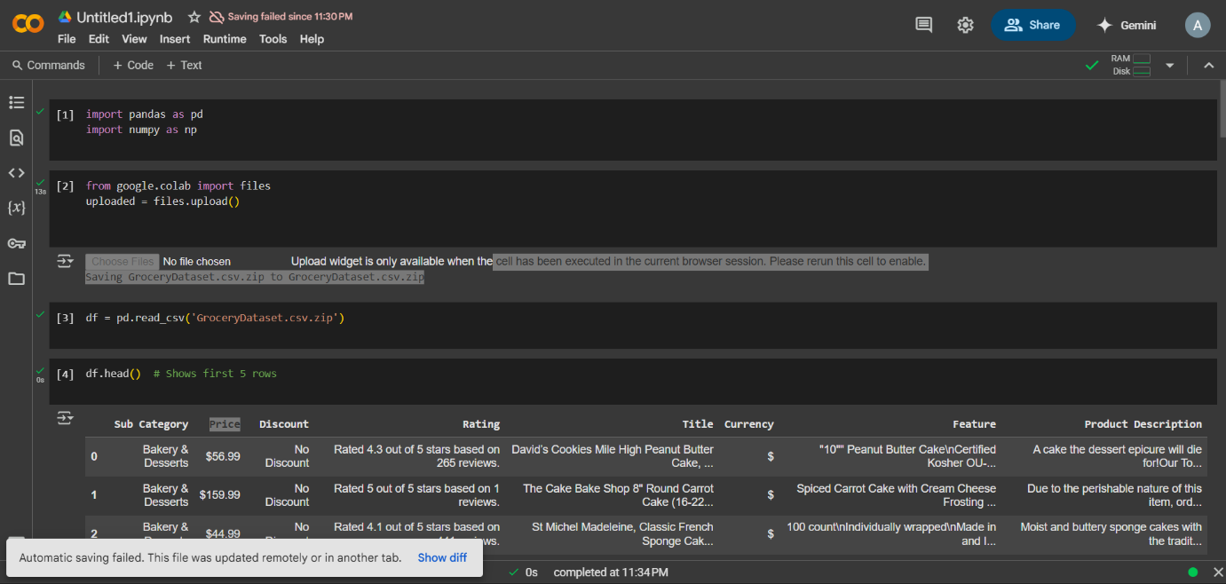**Import dataset and all libraries.**

